**1) http://localhost:4200**

**We will view the application Home page by default.**

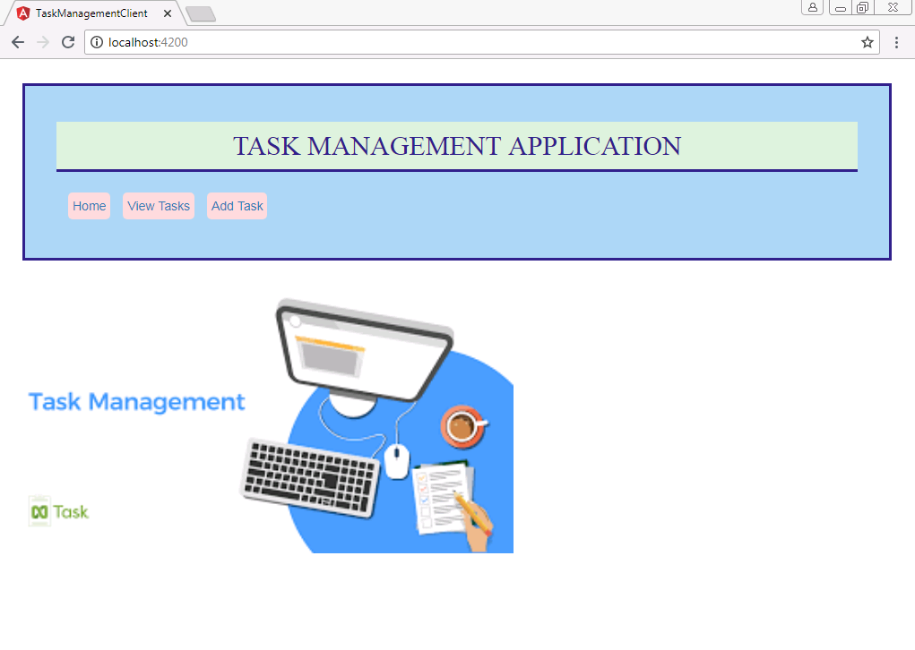

**2) On clicking of View Tasks , we can view all the list of tasks available**

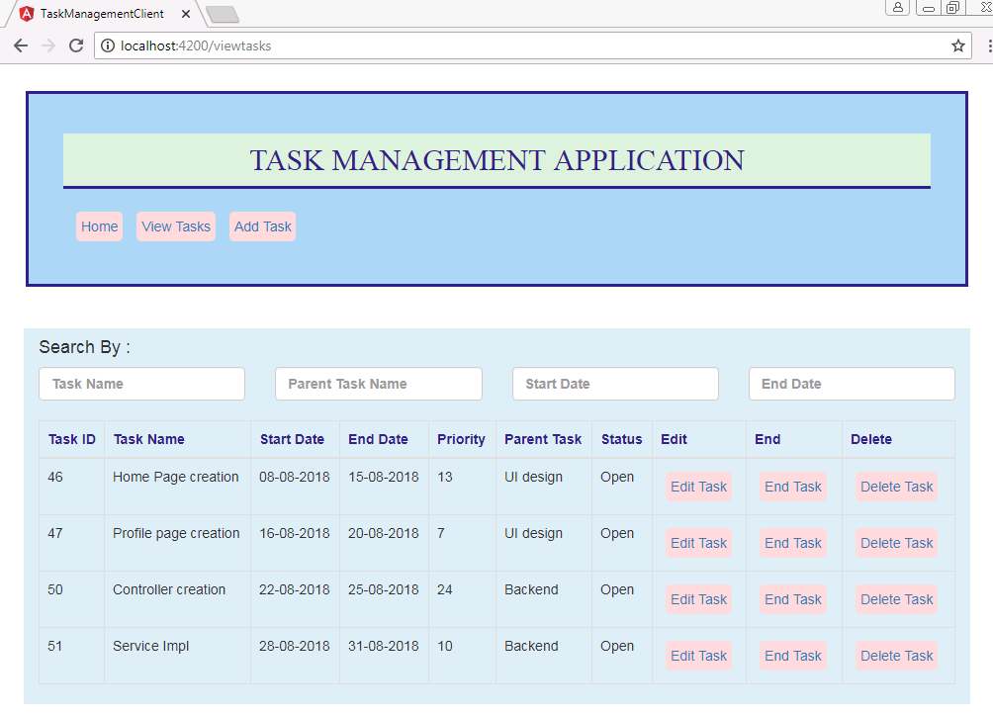

**3)** **On clicking of Add Task , we can add a new task to the tasks list.**

**And by default , newly created task status will be "Open".**

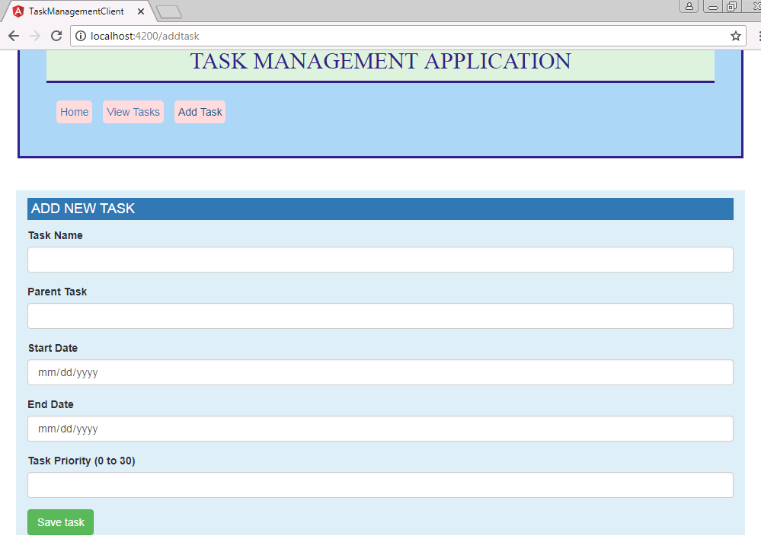

**4) On clicking of Edit Task , we can edit any data of the available tasks.**

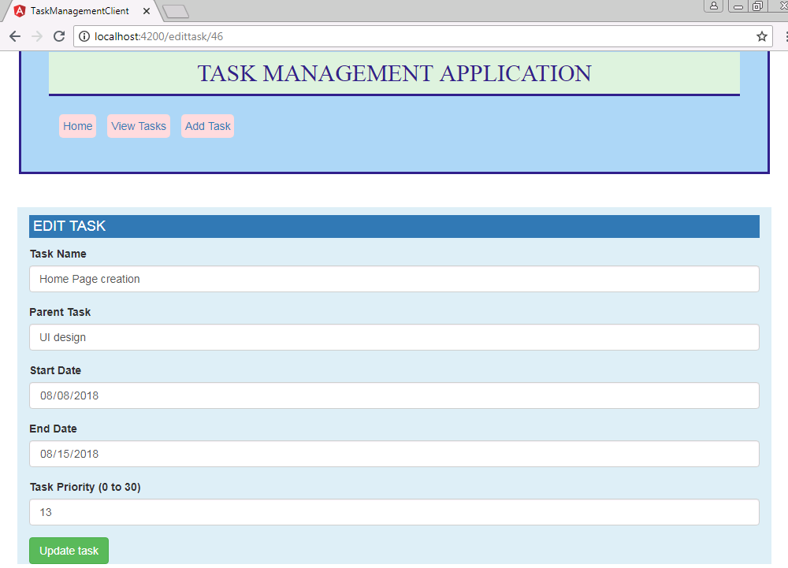

**5) On clicking of End Task, user can complete the task . And once ended the task, Edit option will be removed and the task status will be marked as "Completed".**

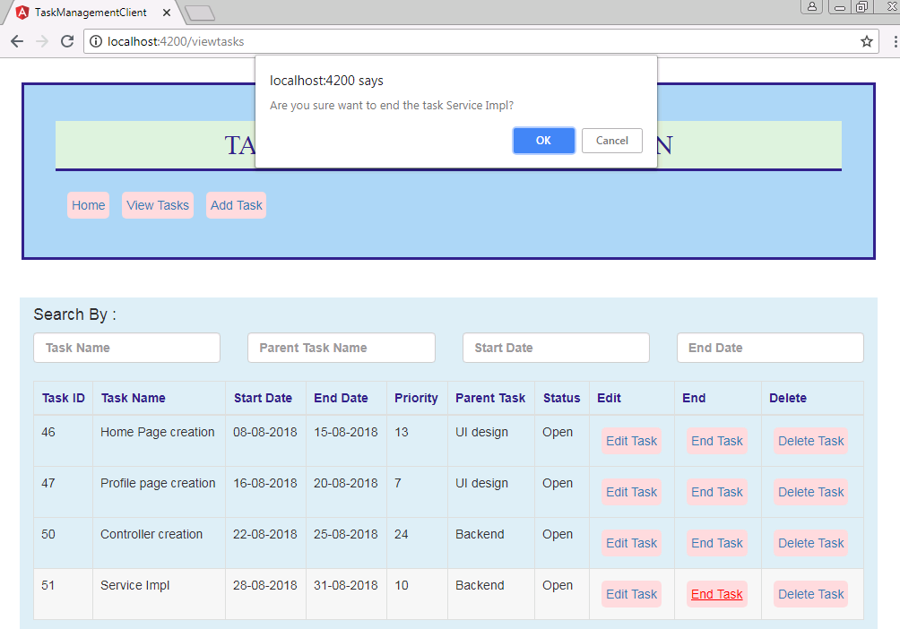

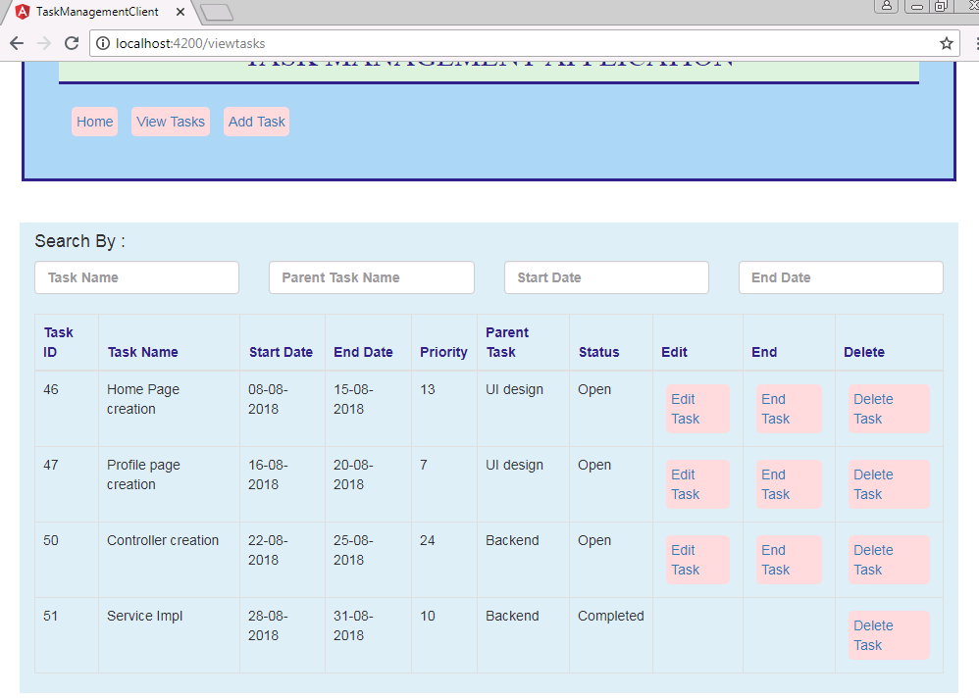

**6) On clicking of Delete Task, user can delete any task from the tasks list.**

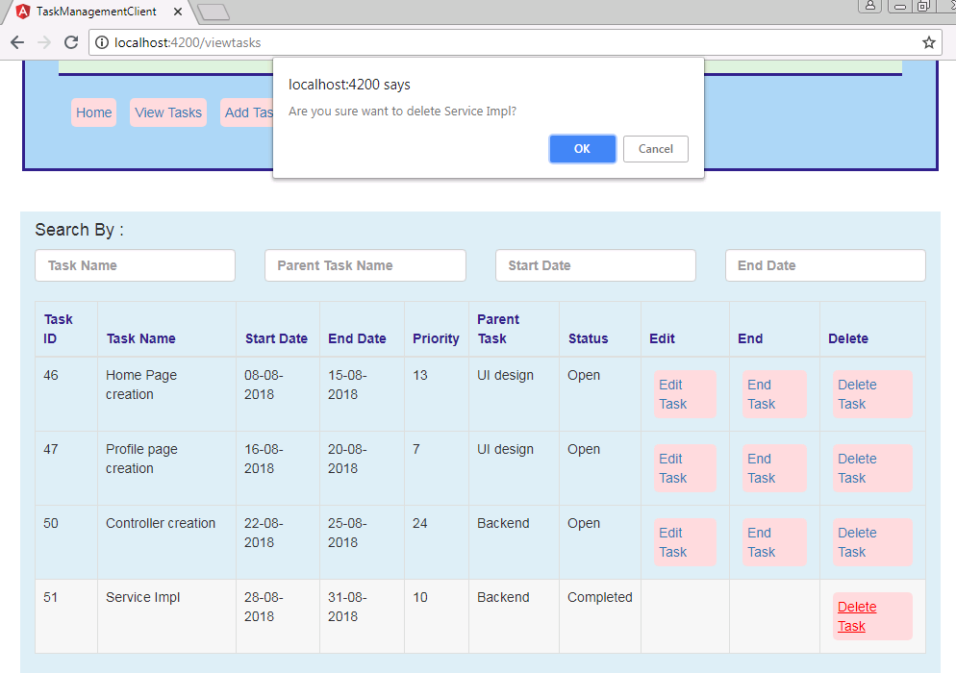

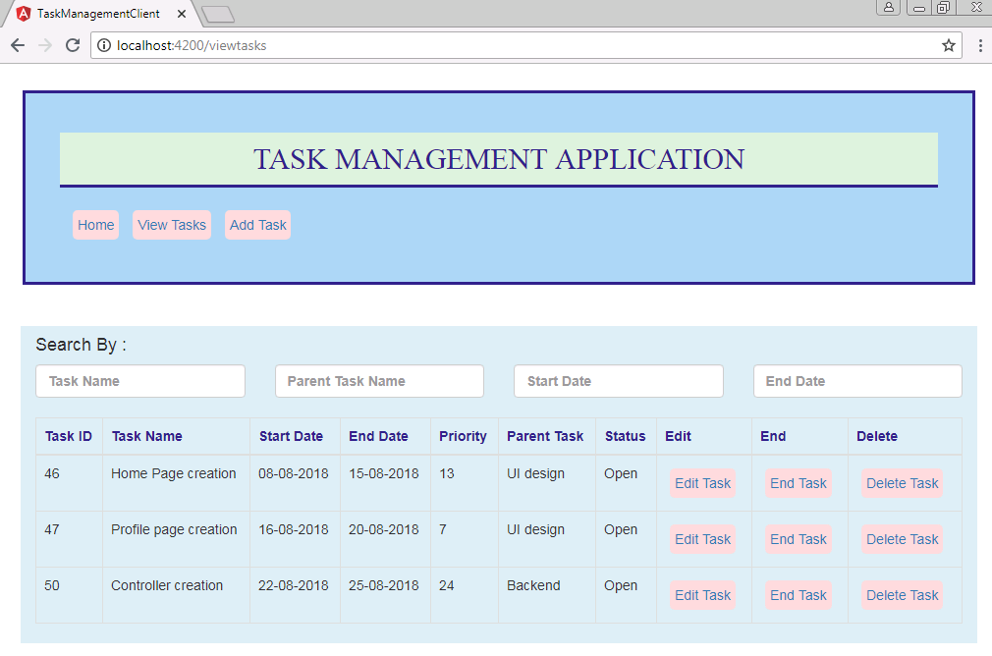

**7) Using the Search option, user can search for tasks by Task Name, Parent Task Name, Start Date and End Date.**

